**Lesson01 Azure Web App Service**

**Notes: -**

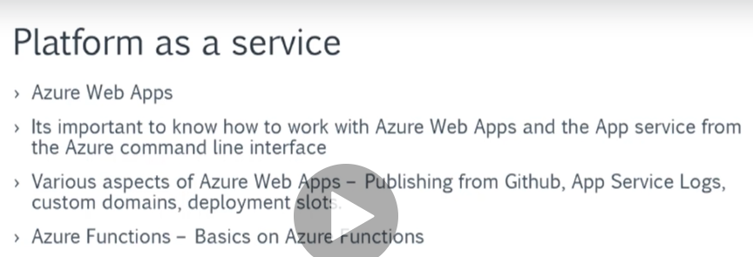

**1-there are 2 ways of deploying your web application into Azure resource**

**A-with using Azure VM (you are responsible to maintain the IIS and security, etc.…)**

**B-with using Azure App Service (its platform as service, so the underlying structure is responsible for handle the security and IIS configuration, etc…)**

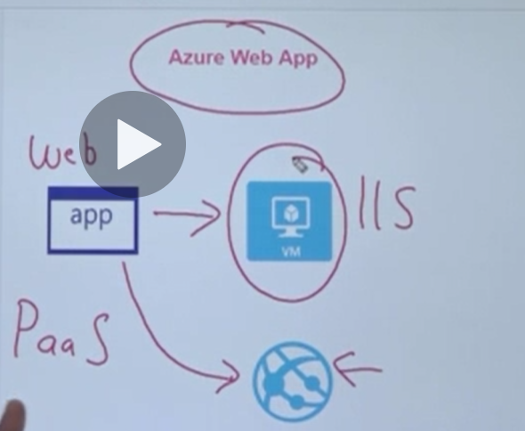

**Advantages: -**

**1-Deployment Slots: which means that you can create 2 versions of app application, one for staging and for production**

**(So, you can have multiple publishes for staging and production, if the QA test the staging publish, you can easily switch to production)**

**2-Backups**

**3-SSL**

**4-Custom Domain App**

**5-you don’t have to maintain the underlying computer infrastructure**

**6-its has features such as Autoscaling and security**

**7-it has DevOps capabilities which include continuous deployment**